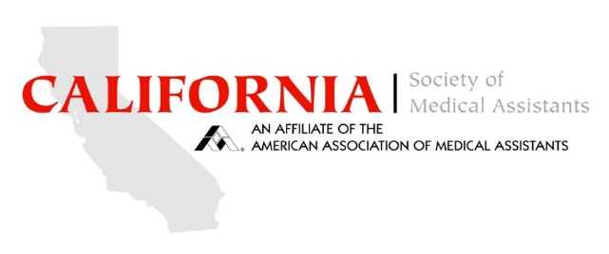

Site Rules and Privacy Policies for CSMA

Copyright
All materials posted on this site are subject to copyrights owned by the California Society of Medical Assistants. CSMA hereby provides limited permission for the user of this site to reproduce, retransmit, or reprint for such user’s own personal use (and for such personal use only) part or all of any document on this site as long as the copyright notice and permission notice contained in such document or portion thereof is included in such reproduction, retransmission, or reprinting. All other reproduction, retransmission, or reprinting of all or part of any document found on this site is expressly prohibited, unless CSMA has expressly granted its prior written consent to so reproduce, retransmit, or reprint the material. All other rights
Trademark
The names, trademarks, service marks, and logos of CSMA appearing on this site may not be used in any advertising or publicity, or otherwise to indicate CSMA’s sponsorship of or affiliation with any product or service, without CSMA’s written permission.

Disclaimers
CSMA is providing information and services on this site and continuing education sessions as a benefit and service in furtherance of CSMA’s non-profit and tax-exempt status. CSMA makes no representations about the suitability of this information and these services for any purpose.
CSMA does not exert editorial control over the materials that are posted/presented by third parties onto the site or materials that are e-mailed by third parties to any other persons. CSMA is not responsible for any material posted by any third party. CSMA specifically disclaims any and all liability for any claims or damages which may result from any postings/presentations by third parties

Privacy
We will endeavor to keep all e-mail private, viewable only by you and the person to whom you address it, except:

We, as site operators, may need to look at your e-mail if we believe it is necessary to protect ourselves or other visitors from injury or damage. For example, if we have reason to believe a visitor is involved in activities that violate our rules or applicable law, which could lead the authorities to seize or search this site’s server, we may review his or her e-mail for our own protection. We will not, however, monitor electronic mail unless we obtain reason to believe it is being misused.

We will not deliberately disclose electronic mail to other visitors. If we believe certain electronic mail is connected with activities that violate our rules or applicable law, we may disclose it to the authorities to protect ourselves and other callers.

Remember that the person to whom you send electronic mail is not legally required to keep it secret. The sender or receiver of electronic mail has the right to make it public.

Site Rules and Privacy Policies for CSMA

If a governmental authority ever searches or seizes this site’s server, it may gain access to your private e-mail. In that case, we cannot assure they will not review it. Remember that you have personal rights of privacy that even the government cannot legally violate, though you may have to go to court to enforce those rights.

All electronic messages may be copied as a routine matter and may be destroyed on a regular basis. CSMA disclaims any responsibility to maintain copies of any such communication or to assure that such information is deleted.

Limitation of Liability and Indemnity
You agree that CSMA will not be responsible to you for any indirect, consequential, special, or punitive damages or losses you may incur in connection with visiting this site or any of the data or other materials transmitted through or residing on this site, even if we have been advised of the possibility of such damage or loss. In addition, you agree to defend and indemnify CSMA and hold CSMA harmless from and against any and all claims, proceedings, damages, injuries, liabilities, losses, costs and expenses (including reasonable attorneys' fees) relating to any acts or omissions by you or materials or information transmitted by you in connection with our forum leading wholly or partially to claims against CSMA or this site by other callers or third parties.

